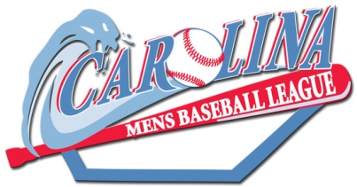2018 Regular Season 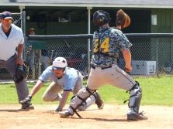
Carolina Mens Baseball League, Inc. – All Divisions Player Application Fee:
If paid on or before March 18th > ___$275 Red &White Div. ___$225 Active Military
If paid after March 18th > ___ $300 Red & White Div. ___ $250 Active Military
T shirt size___ FREE FOR NEW PLAYERS
Name:______________________________________ LAST FIRST
Email Address: ______________________________
Street Address: ___________________________________ ____________________________________________________ CITY STATE ZIPCODE
Date of Birth: ________________________________ Age____ (MM/DD/YYYY)
Phone Number: ____________ ____________ HOME MOBILE
Emergency Contact: __________________________ Driver’s License _________ NAME RELATIONSHIP PHONE State # Circle highest Experience: Little League High School College Professional (if pro ball indicate last year played)
How did you learn about the CMBL? Internet__ Radio__ Flyer__ Road Sign__ Friend__ Other (please specify)______________
IF TWO-SIDED, PLEASE SIGN ON REVERSE SIDE
I hereby agree and consent to the following conditions of participation in the Carolina Mens Baseball League ( the “League” or “CMBL” ) :
1. I warrant and represent that the information provided herein is true and accurate. I consent to assignment to a team by the League based on its sole determination of the best interest of the League and competitive balance.
2. I acknowledge that I have read and am familiar with the Code of Conduct and Rules established by the CMBL and that I will comply with and obey them at all times while I am participating in League activities. Specifically, I understand that unsportsmanlike behavior, malicious, flagrant, or unsafe conduct, fighting or use of abusive, or offensive language will not be tolerated by the CMBL and engaging in such conduct may subject me to suspension, fine or expulsion from the League and forfeiture of all fees paid.
3. I certify that I am physically and medically capable of participating in League activities and games and specifically assume all risks attendant to playing the game of baseball and associated activities. I further agree to comport myself in a manner that will ensure the safety of myself and fellow participants and others at all times during League activities. I knowingly waive any and all claims, suits, actions of any nature whatsoever against the League or any entity providing facilities or services to the League or its participants and agree to hold the League harmless for any and all claims against it or its providers or vendors. I fully realize that any expenses incurred as a result of my participation in League activities are my sole responsibility. By signing this agreement, I release and absolve the League and its providers and vendors from any liabilities, claims, expenses, or costs relating to League activities.
4. I realize that I am joining the League in order to engage in recreational, competitive baseball and that there certain risks inherent in playing baseball that I knowingly assume. I agree and acknowledge that if I am unable to complete the season for whatever reason, I am not entitled to a refund. Fees paid are not transferable. Any deviation from this policy is subject to the sole discretion of the CMBL. It is further agreed and acknowledged that CMBL or its agents may from time to time take photographs or video of participants in League activities and that the images, sounds and likenesses of the participants are copyrighted by CMBL and may be used by CMBL on its website and other media or for other purposes.
I fully agree that the terms and conditions of this Agreement are legally binding. Signature_________________________________ Date _______
Help us improve playing conditions. Last year we refurbished mounds and batters boxes. We plan to do more this year. _ Check here to donate for field improvement fund ($10_ $25_$50 _ )
__ Check here to volunteer for field work team

