Wed May 05, 2010 11:32 am EDT

The 'Code': Ten unwritten baseball rules you might not know
By Jason Turbow
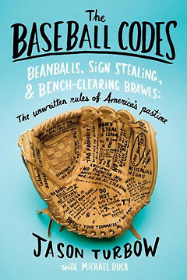
Ed. note: Jason Turbow is author of the new, critically-acclaimed book "The Baseball Codes." It's available for purchase through the book's Web site.
Last month, when A's pitcher Dallas Braden(notes) called outAlex Rodriguez(notes) for cutting across the Oakland Coliseum mound, the country was informed of a small slice of baseball's Code that had lain mostly dormant in recent memory.
It was only one of a litany of unwritten rules that covers major leaguers' actions, designed essentially to preserve a baseline level of respect between competitors. They constitute the moral fabric of the game.
The best known of these rules tells players not to steal a base when their team holds a big lead in the late innings of a game. Others include barring overt displays of exuberance in all but the most extreme circumstances; the hitter who watches his own home runs is the most egregious of violators in this category.
Many fans have heard of these rules (Alex Rodriguez himself was unaware of one). Some sections of the Code, however, fly under the radar (even for baseball insiders, to judge by the number of people within the game who had never heard the rule about restraint from crossing the pitcher's mound).
So, without further delay, here are 10 of baseball's more obscure unwritten rules:
1. Don't swing at the first pitch after back-to-back home runs
This is a matter of courtesy, respect for a pitcher who is clearly struggling, offering just a sliver of daylight with which to regain his senses. When Yankees rookie Chase Wright(notes) gave up back-to-back-to-back-to-back homers against Boston in 2007, the guys who hit numbers three and four — Mike Lowell(notes) andJason Varitek(notes) — each watched a pitch before taking a cut.
"Let him know, okay, I'm not swinging," said Hal McRae. "I know you're out there trying to do a job, and I have to do a job — but you've just given up back-to-back home runs. So I take the first pitch."
2. Don't work the count when your team is up or down by a lot
This is true for both pitchers and hitters. Nobody wants to see the fifth guy on a bullpen's depth chart nibbling on the corners in the late innings of a blowout. Similarly, hitters are expected to swing at anything close. It's an effort to quickly and efficiently end a lopsided contest.
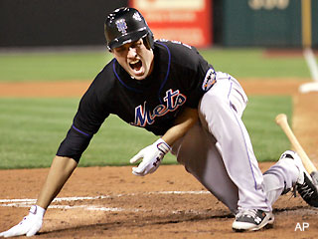
3. When hit by a pitch, don't rub the mark.
This one is all about intimidation or lack thereof. It's a hitter's way of telling the pitcher that his best shot — intentional or otherwise —didn't hurt. Pete Rose made a point of sprinting to first base after being hit, to ensure that he stripped all satisfaction from the pitcher.
"It's a macho thing, like a fighter who gets clocked in the mouth and shakes his head like it didn't hurt him," said Rich Donnelly. "But believe me, it hurts."
Lou Brock was the only hitter Sandy Koufax ever threw at intentionally, and despite the fact that his shoulder was fractured by the pitch, forcing him from the game, never once did he rub the spot. The Washington Post once reported that Don Baylor "was hit by 267 pitches yet never rubbed, even once. Of course, several of the balls had to be hospitalized."
4. Don't stand on the dirt cutout at home plate while a pitcher is warming up
Just as Braden dismissed A-Rod's attempt to enter his sacred space, the area around the plate is meant only for the hitter, and then only when it's time for him to hit. Should a pitcher be getting loose before an at-bat, it's strictly off-limits. "I stay as far away from the cutout as I can when the pitcher is warming up," saidKen Griffey Jr.(notes) "If they could, they should put the on-deck circle in left field to make me happy. I don't want anything to do with messing with the pitcher when he's getting ready."
5. Don't walk in front of a catcher or umpire when getting into batter's box
This is respect, pure and simple. If the line from your dugout to the batter's box takes you between the pitcher and the catcher, walk around. Like the A-Rod incident, you'll likely never hear about this one until a player is called out for brazenly violating it.
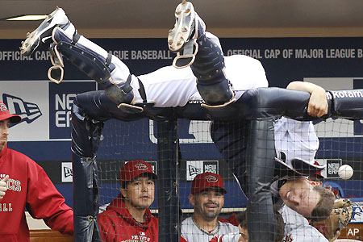
6. Don't help the opposition make a play (bracing them from falling into the dugout, etc.)
In 1998, Dodgers left fielder Matt Luke braced Arizona's Andy Fox as the third baseman staggered into the Los Angeles dugout while chasing a pop fly. He knew the Code, but he had also been Fox's roommate in multiple levels of the Yankees' minor-league system, and was so tight with him that Fox had served as an usher in his wedding. Even then, he had his limits. "I waited until he made the play," said Luke in the Riverside Press Enterprise. "I wanted to prevent an injury. We're competing out there, and not for one second do I want to help the opposition."
7. Relievers take it easy when facing other relievers
The caveat to this piece of the Code is that for the most part, relievers don't step to the plate in close games, which gives their counterparts on the opposing team some leeway in their approach. "You'd probably give them all fastballs," said Dave LaRoche. "It was just a professional courtesy type of thing. Here it is — I'll give you a chance to hit it if you can."
8. Follow the umpire's Code when addressing them on the field.
This is a book in itself. How one talks to umpires goes a long way toward getting favorable calls, or at least not getting thrown out of a game. ("That call was horse----" is generally acceptable; "You're horse----" is never acceptable.) Some savvy teams go so far as to post headshots and bios in the clubhouse for the umps working that day's game, so that players can butter them up a bit.
Still, there are ways to express anger without getting tossed. After umpire Shag Crawford called Dick Groat out on a play at second base, Groat told him, "You're still the second best umpire in the league." Then he added that the other 19 umpires were tied for first.
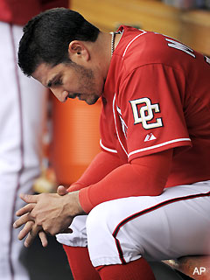
9. Pitchers stay in the dugout at least until the end of the inning in which they get pulled
This is purely about respect for one's teammates. "I know you're having a tough day, but give your teammates the respect to stay out here until the end of the inning," saidSean Casey(notes). "You don't want to show that you think the game's already lost."
10. Pitchers never show up their fielders
This doesn't happen frequently, but when it does, players notice. One pitcher who made a habit of excessive body language on the mound was Gaylord Perry, who would put his hands on his hips and stare down fielders who made errors behind him.
"That bothered me because nobody glared at him if he gave up a home run or something like that," said Dave Nelson, Perry's teammate on the Rangers. "I always felt like I deserved the same respect because I'm out there busting my butt just like he is, and if I make an error, it wasn't because I was doing it on purpose."
Perry's teammate in Cleveland, Oscar Gamble, had a different take: "If you don't do right, if you miss a ball you should have caught, you expect the fans to boo you," he said. "And this fan, Gaylord, was a player. That's the way I looked at it."
Perry, however, was occasionally able to find his fielders innocent of wrongdoing. Once, after shortstop Todd Cruz fielded a grounder and air-mailed the ball into the stands, Perry withheld judgment. "Too much stuff on the ball," he said after the game.
For more on baseball's unwritten rules, visit TheBaseballCodes.com

