**FATHER & SON BASEBALL**

**TOURNAMENT JULY 24-25**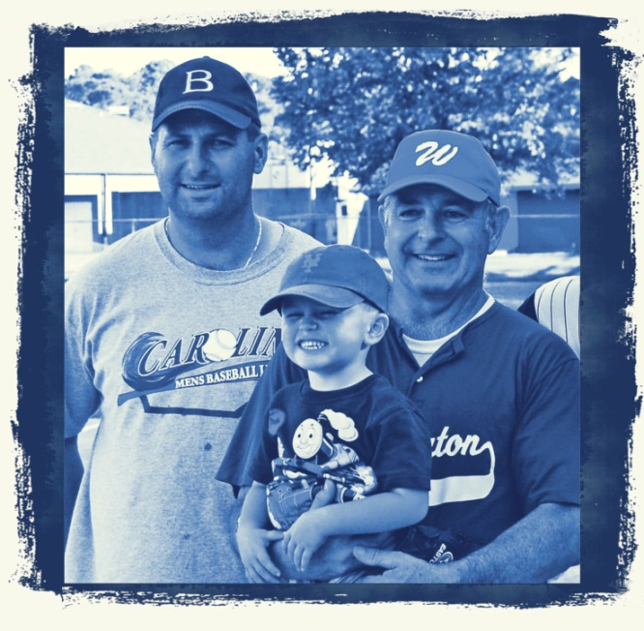

**Where: Godwin Stadium,**

**Wilmington, NC**

**What: Wood Bat Baseball**

**How: Call 910-465-0535**

**When: JULY 24-25**

**Who:Fathers +Sons .**

**Partial or full**

**teams welcome.**

**FREE Team Jerseys**

**Two game guarantee**

**Proceeds to benefit**

